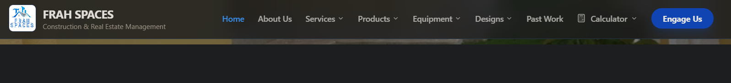
Remove – Construction and real estate management. The section just below the logo.
Logo --- https://drive.google.com/file/d/1aoW_zyIKFuX57oJvuBO-i3cs72t2Dwhb/view?usp=drive_link
This one has no background and should be masked in the case of this page.
This is how the background-less logo appears on my end: 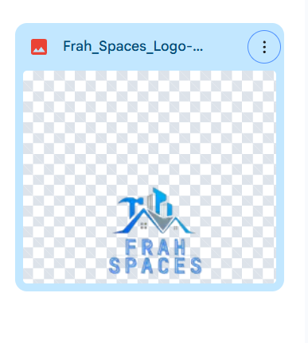

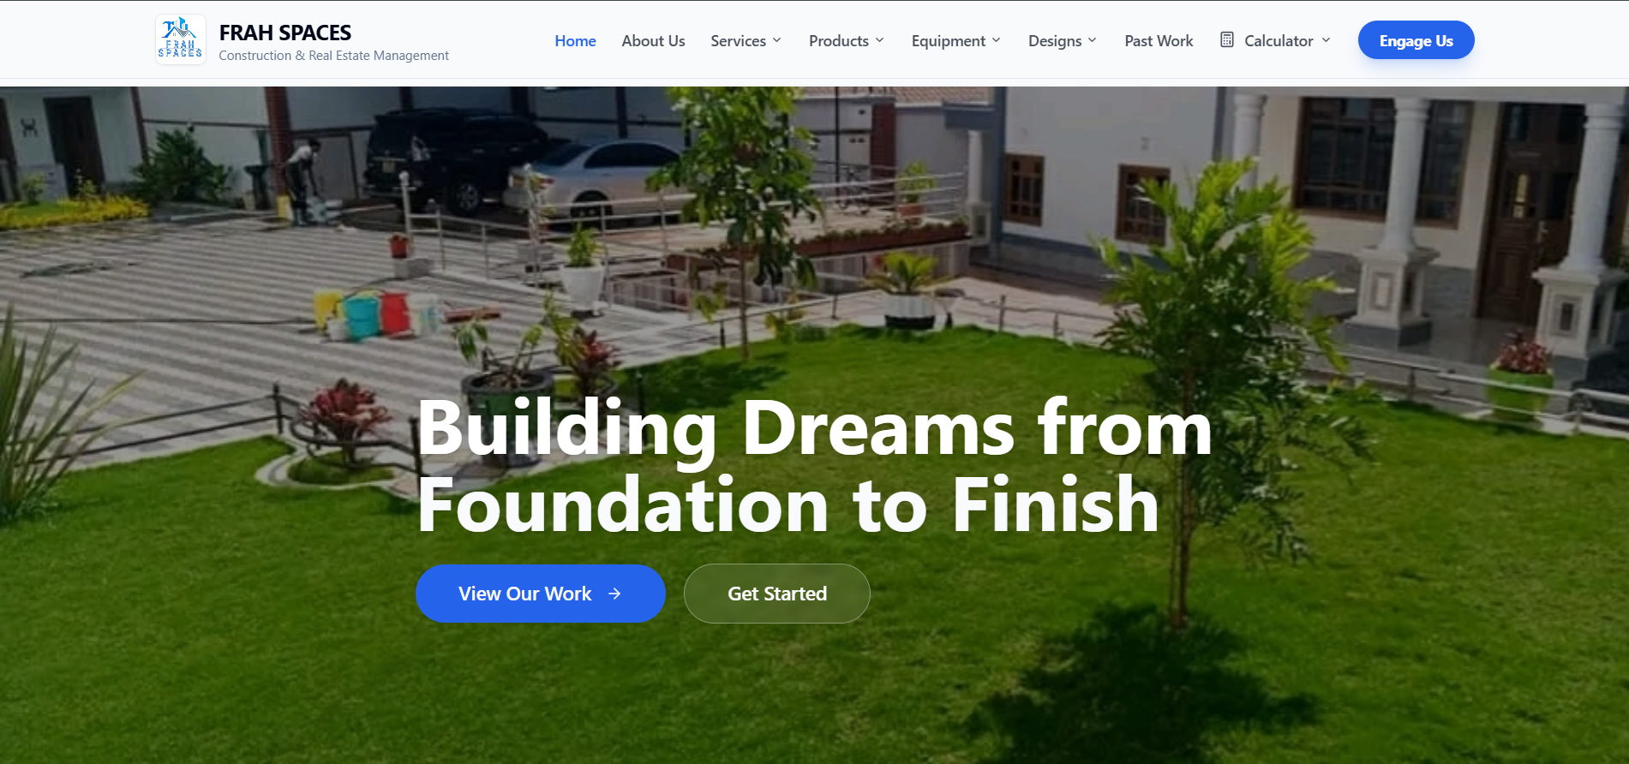
Home page pics. Only use any of the pics linked below:
- https://drive.google.com/file/d/1U9xTFaFa8-12hY8uZvPmZd3yaFZPTDeD/view?usp=drive_link
- https://drive.google.com/file/d/1XySBB-MdH9ezC7HtwCdqIkTSMuVt6IOT/view?usp=drive_link
- https://drive.google.com/file/d/1lDeF_Z9GecUNfcHdJOcs_U06wKPA2e_L/view?usp=drive_link
- https://drive.google.com/file/d/1CqzkPrprkqQKVNAvO1dUxd3Esv13d-Ha/view?usp=drive_link
- https://drive.google.com/file/d/1TOZWpGLlXarJj5rutXPrHin1BUrl93s0/view?usp=drive_link

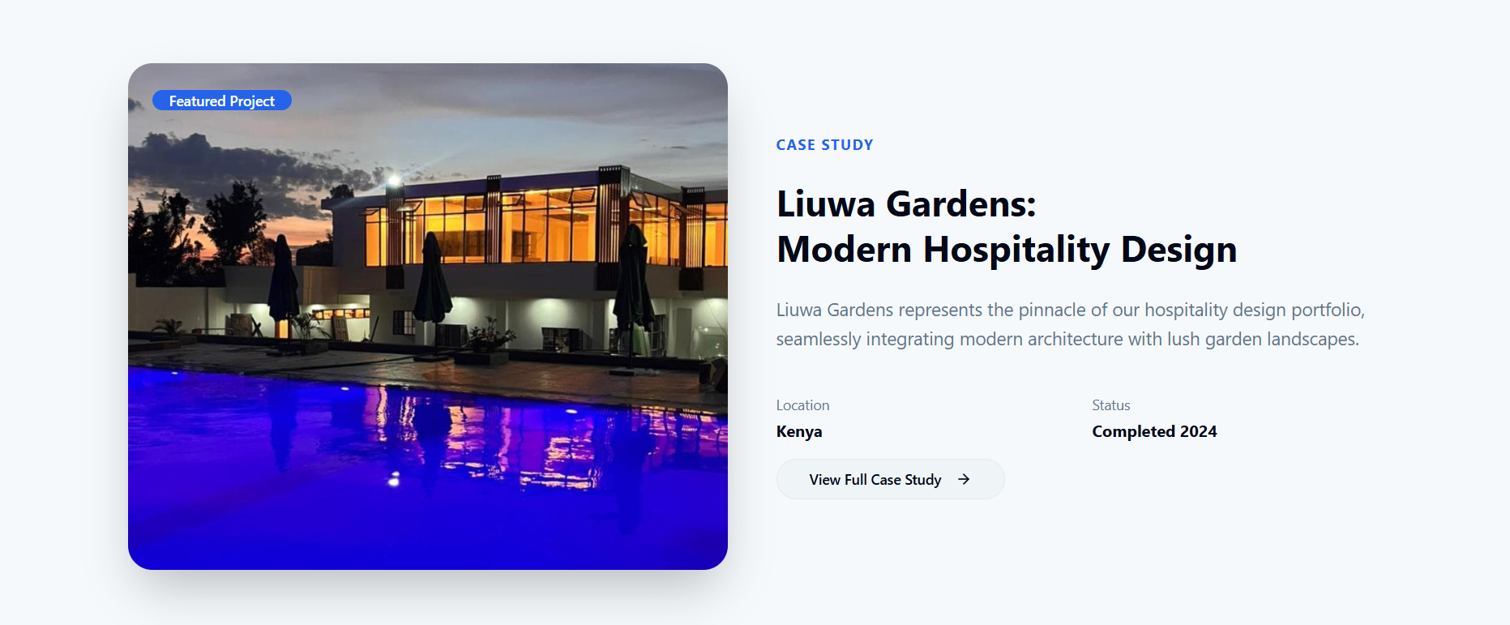

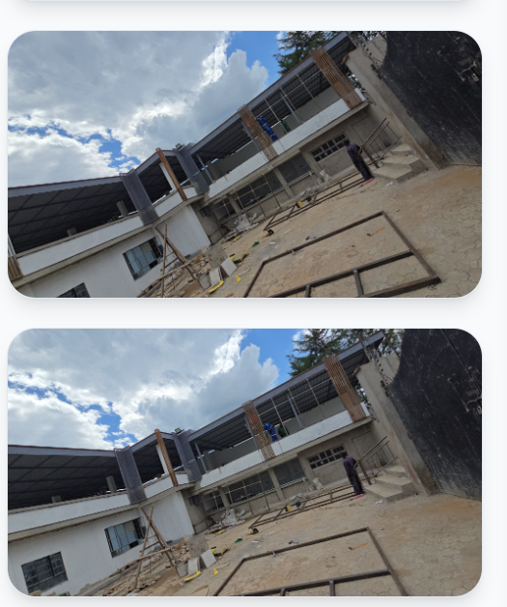
For Liuwa Case Study, these two photos are the same. Replace one with: https://drive.google.com/file/d/15E_7TkQpVOReBGbk9i49luaS_2ZamQrn/view?usp=drive_link

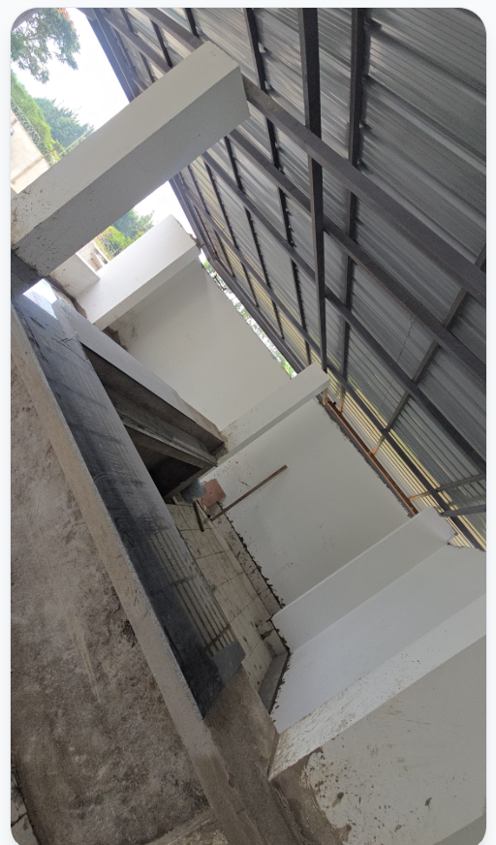
For the Liuwa case study still, completely remove this pic which appears twice. Replace gaps that will be left with below pics:
- https://drive.google.com/file/d/1kc5wVGYZjNqgA5kRwfsWBddX94n52HU9/view?usp=drive_link
- https://drive.google.com/file/d/1UeTEejic8lrZDJmzFMIyZQIrrBcZHHxy/view?usp=drive_link
Please try to find room for this pic too in the case study:
https://drive.google.com/file/d/12HKZFwQTp7VgJWVqeedoYApnThKcYW1O/view?usp=drive_link
For the case study, you could also include below video:
https://drive.google.com/file/d/1SlA26_4MuyY39Uel-Uzur6YhtUOnXFqU/view?usp=drive_link

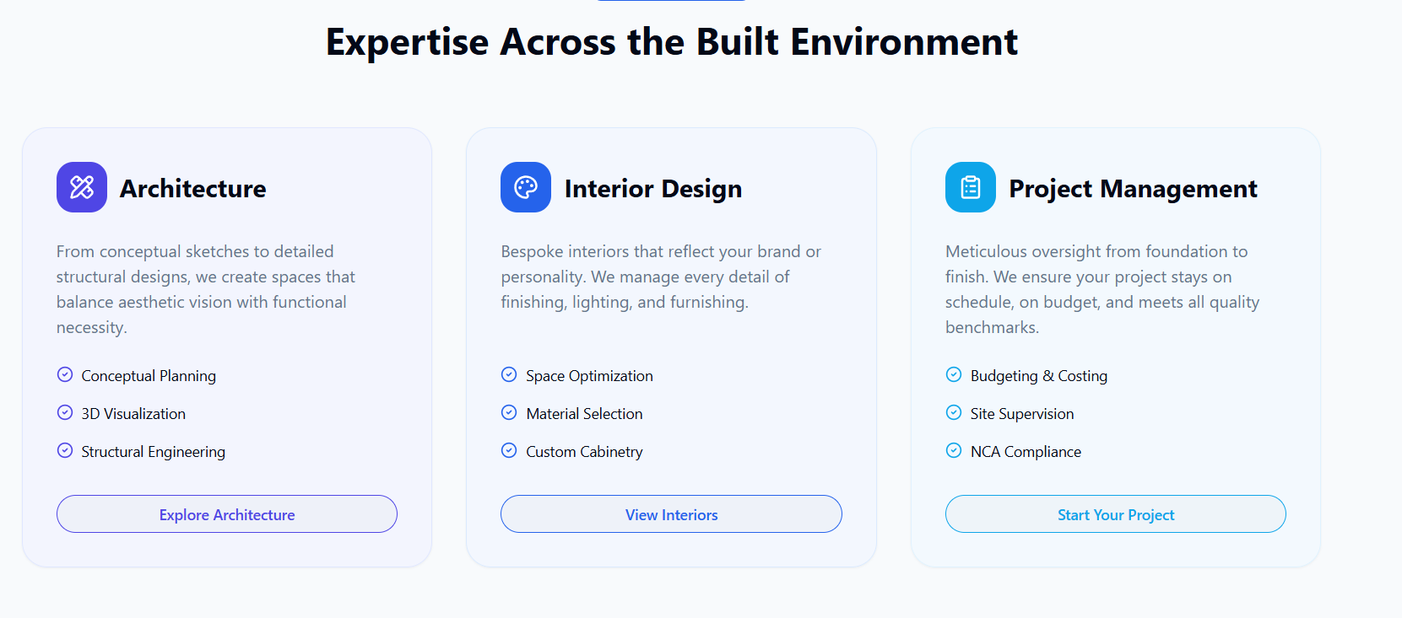
For the section on expertise, our pillars are as below:
Pillar I: Design
- Architectural
- Structural
- Mechanical, Electrical and Plumbing (MEP)
- Interior
- Landscaping
For us, expertise in design doesn't just mean "making it look good." It means we understand spatial functionality, building codes, and material science. We do not treat design as a purely aesthetic exercise; it is the production of a coordinated architectural vision that takes into account the users needs/resources, latest developments, environmental qualities and related factors.
Pillar II: Construction
- Turnkey/EPC
- Labour-based
- Supplies
- Equipment
We manage the physical assembly—from foundations and superstructure to the building envelope—offering the choice between a Labour-Based model for client-led procurement or a full EPC (Engineering, Procurement, and Construction) framework for a fixed-price, turnkey delivery. A strategic procurement framework where we leverage our supply chain to source, verify, and deliver high-spec materials and finishes, ensuring site-wide quality compliance. A logistics-heavy model focused on the mobilization and management of specialized tools, plant and heavy machinery required to achieve construction milestones.
Pillar III: Project Management
This layer enforces fiduciary oversight through systematic auditing, scheduling, and Quality Assurance (QA/QC), ensuring that "value for money" is maintained and that technical integrity is never compromised for speed. We ensure that work progresses without compromising technical integrity. We enforce a "Zero Rework" policy by validating each stage against the approved BIM model. We handle the administrative complexities of the project closeout, ensuring all compliance markers are met.

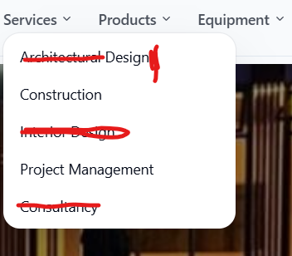
Amounts in red are cancelled. Please implement.

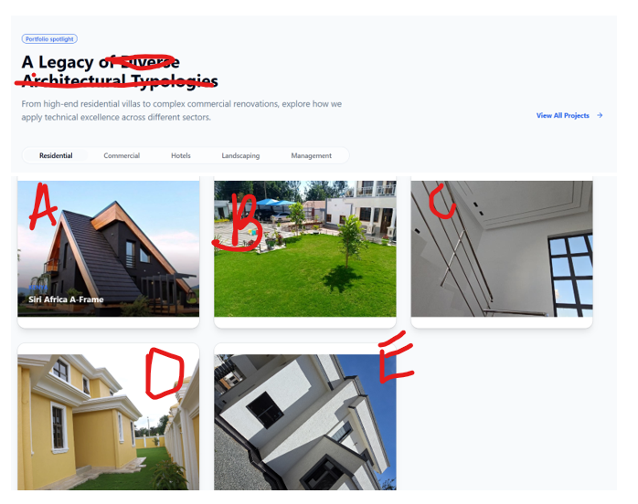

Delete amounts that I struck out above.
A
Use the below image as the cover image for project:
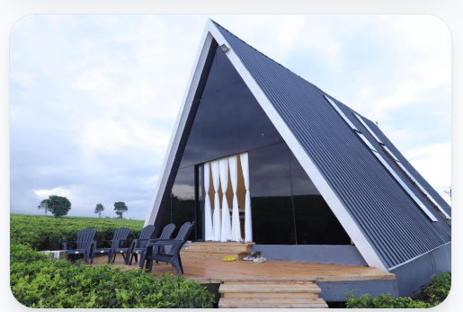
The below are not showing.
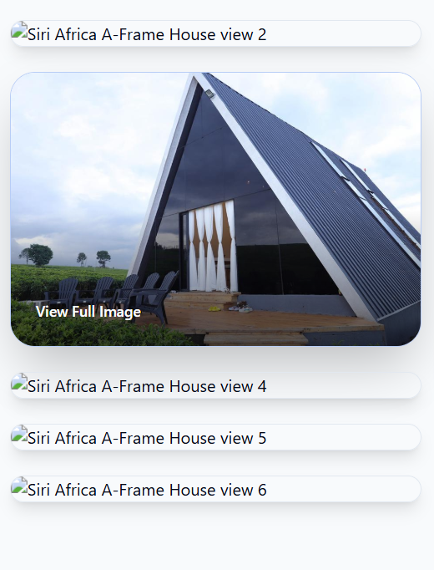

B
Use this as cover pic:
https://drive.google.com/file/d/1CqzkPrprkqQKVNAvO1dUxd3Esv13d-Ha/view?usp=drive_link
Also, please update the page to show actual pics. Realized some pics are not from that project and therefore will mislead anyone looking at the website.

C
Use this as a cover pic:
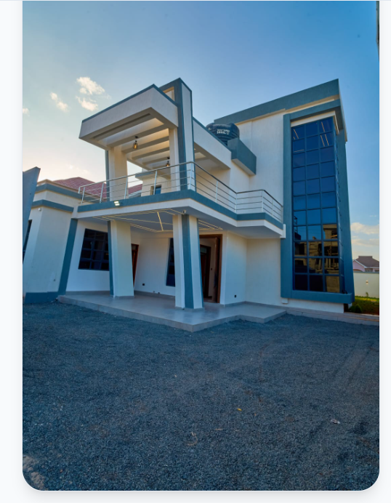

The above photos are identical. Please replace both with below:
- https://drive.google.com/file/d/13qRN098tgAw9Z7DpCjz9XUr3ozalia5G/view?usp=drive_link
- https://drive.google.com/file/d/1dUDyNpcx9TjyPv7Vhj9c7frcU6i9BEbI/view?usp=drive_link
D
Use this as cover image:
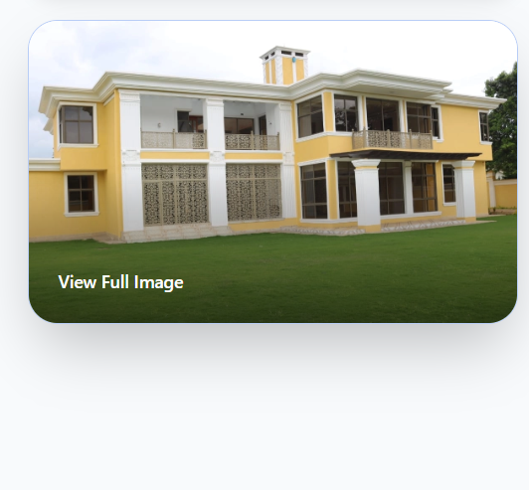

Also, note that View Full Image does not work. Please, no need for full image. Omit that option altogether.
Add below pics:
https://drive.google.com/file/d/1-F7qsZ-g3qjkO9pF00cBJ2e5ARHzdZrz/view?usp=drive_link
https://drive.google.com/file/d/19m2XnFqUyhE64Wl9W4AyJjaMHRXJEQ3p/view?usp=drive_link
https://drive.google.com/file/d/1a26qpc6sC4meJJMphiFgL4-KkDgaH9nE/view?usp=drive_link
https://drive.google.com/file/d/1XaNRKcJBIoS6Ks1kG_byGKm3NwIjPUp7/view?usp=drive_link

Replace text in website with below text:

Karen House
This residence in Karen is a testament to contemporary minimalist design. The project focused on creating a seamless flow between indoor and outdoor spaces, utilizing large windows to flood the interior with natural light. High-quality finishes and custom cabinetry throughout the house reflect the client's desire for a sophisticated yet comfortable home.

E
Use below pic as cover image
https://drive.google.com/file/d/1yjo9CX4cPDgvamGMi4xU6jyjiEdM8I3H/view?usp=drive_link

F
Add these pics too:
https://drive.google.com/drive/folders/1pMinTuWawE81NbkArnwo3kWHdu-2PKux?usp=drive_link

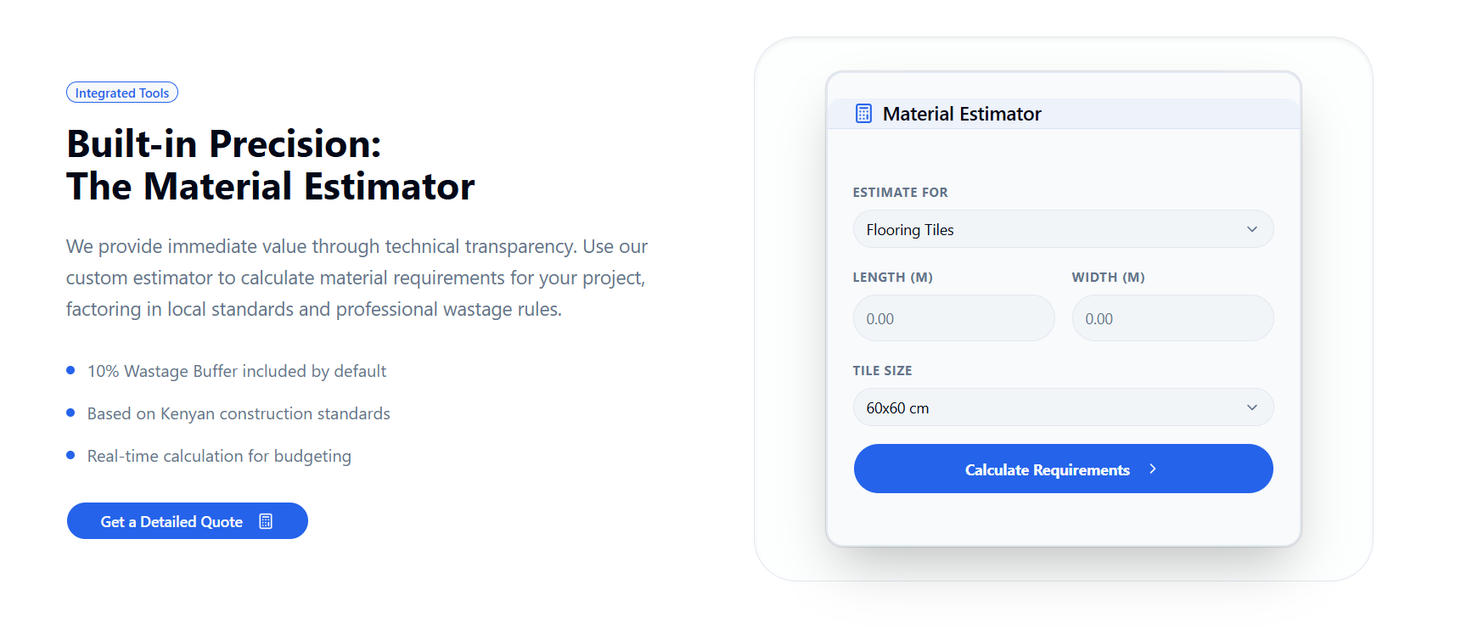

Replace the section below, with the company profile: https://drive.google.com/file/d/1B6ZhSrTLstiXk4LNqFctC9AFTKfahCFo/view?usp=drive_link
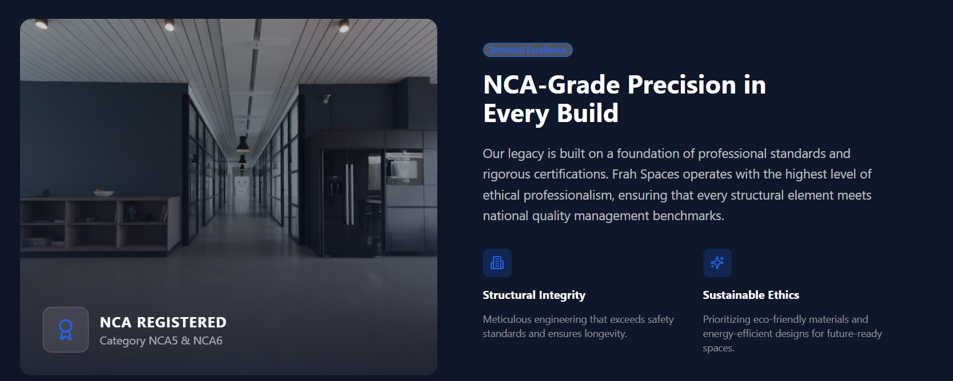

Replace below content with this list:
Pillar I: Design
- Architectural
- Structural
- Mechanical, Electrical and Plumbing (MEP)
- Interior
- Landscaping
Pillar II: Construction
- Engineering Procurement Construction (EPC/Turnkey)
- Labour-based
- Supplies
- Equipment
Pillar III: Project Management
- Construction Project Management
- Quality Control
- Progress Assessment
- Liaison
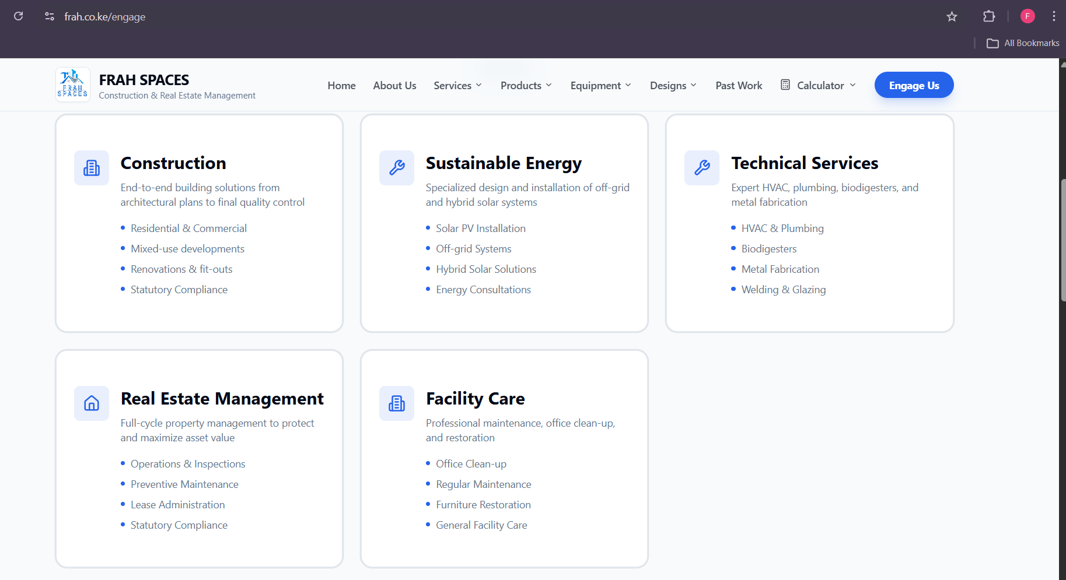

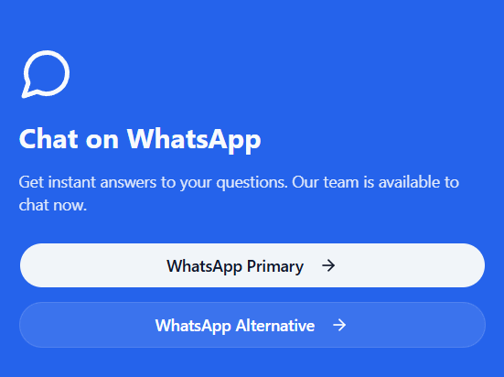
WhatsApp Line 1 - +254 711 44 12 45
WhatsApp Line 2 - +254 721 17 57 35

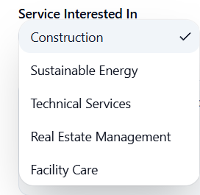
Replace the above services with below:
- Design
- Construction
- Project Management

Frah Spaces is building homes and bringing dreams to life, one project at a time.
Fourways Business Park, Kiambu Road.

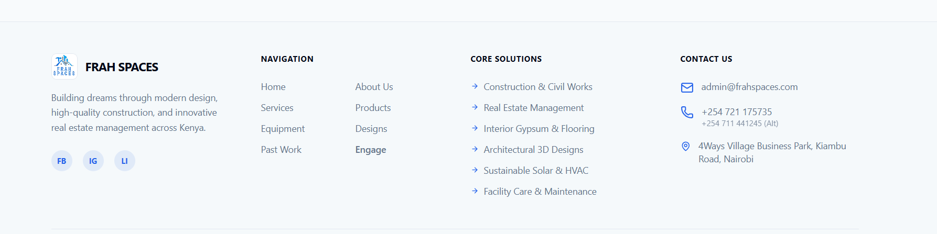
Replace core solutions above with below:
Pillar I: Design
- Architectural
- Structural
- Mechanical, Electrical and Plumbing (MEP)
- Interior
- Landscaping
Pillar II: Construction
- Engineering Procurement Construction (EPC/Turnkey)
- Labour-based
- Supplies
- Equipment
Pillar III: Project Management
- Construction Project Management
- Quality Control
- Progress Assessment
- Liaison

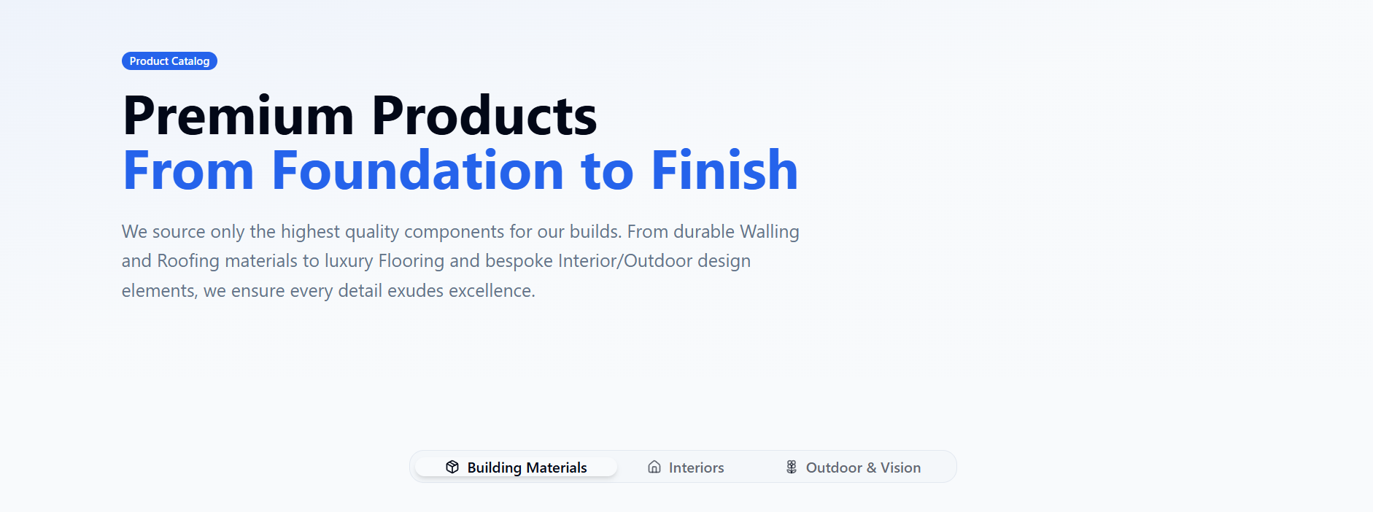
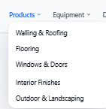
• Walling
• Roofing
• Flooring
• Openings
• Finishes
• Outdoor

Find Product Pics via this link. Please make sure to incorporate all:
https://drive.google.com/drive/folders/1jYlud9uwX6Yr2QlWuedkKrdkrQiIssbc

Replace the contact section with Whatsapp (+254 711 44 12 45) OR Call (+254 721 17 57 35):
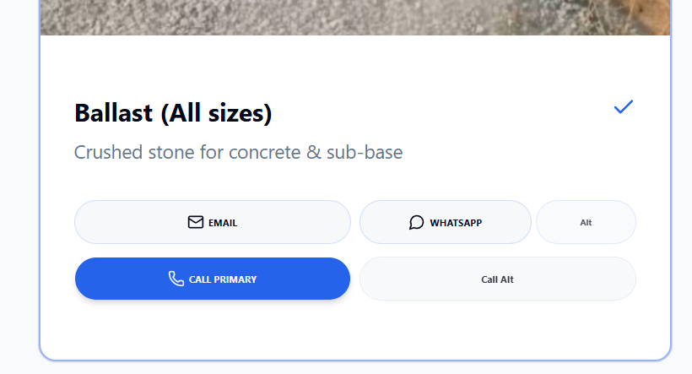

These pics hazi load:
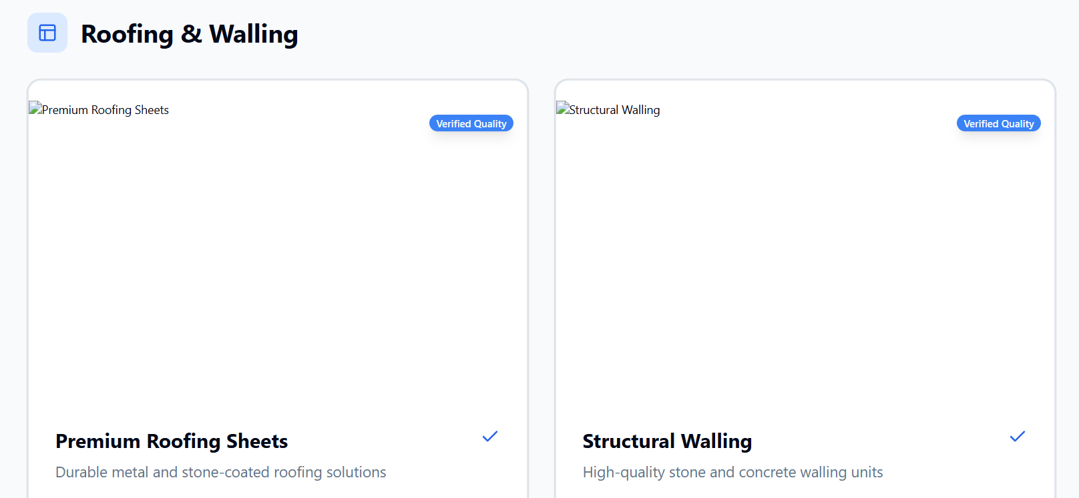

Structural timber can appear in walling as well as roofing.
Plywood, MDF and other manufactured wood can fall under Interiors
Therefore, this “timber” section should be omitted:

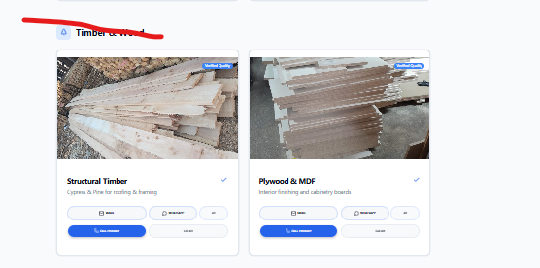

This “Bulk sourcing” section should be omitted:
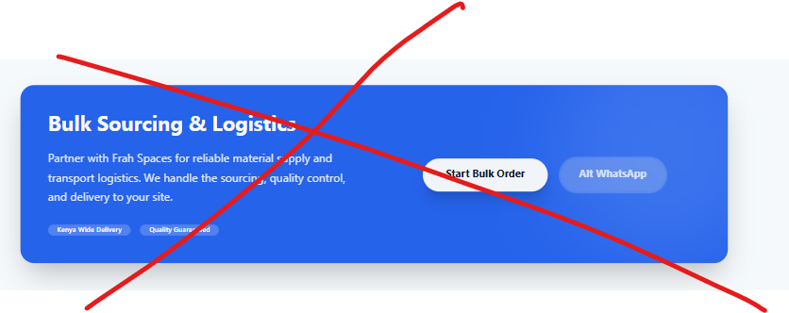

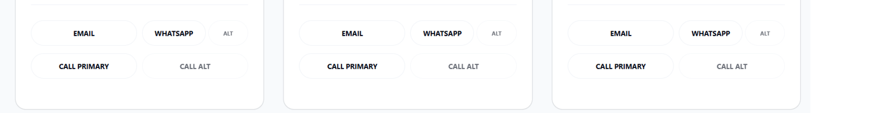
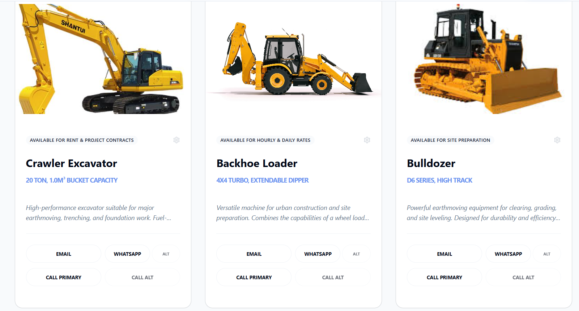
Delete “Talk to logistics” bit. Instead, Talk to us – Leads to +254 721 17 57 35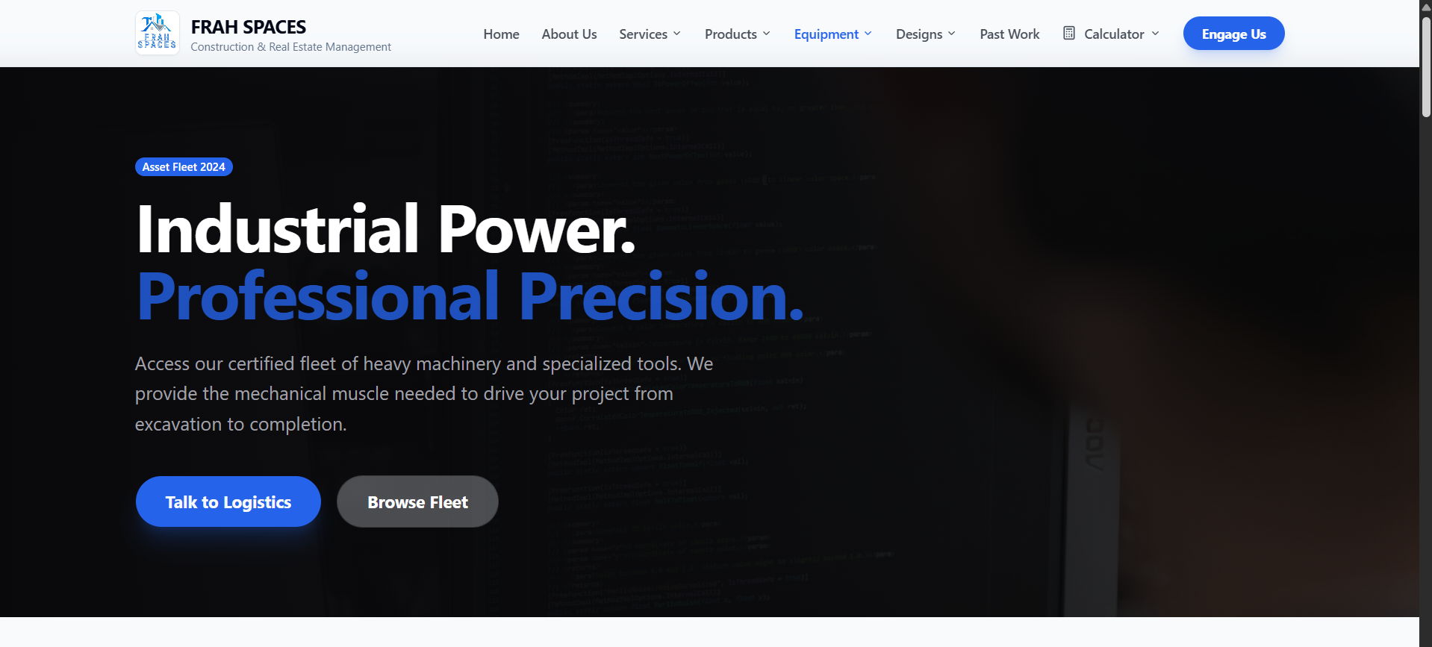
Design should be split into:
- Floorplans
- 2D renders
- 3D renders
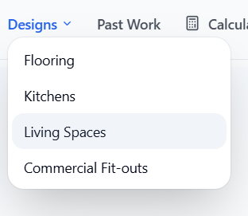

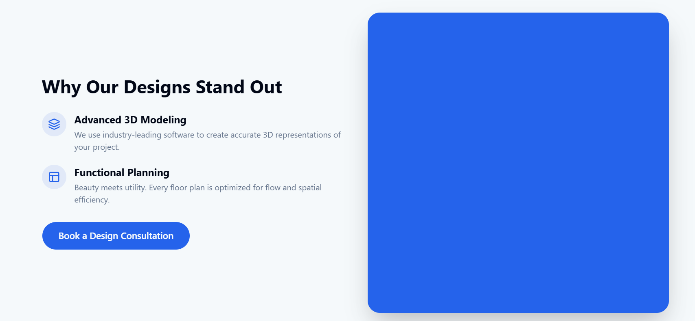

For below, use the relevant platform icons and handles as listed below. We need to make the links functional:
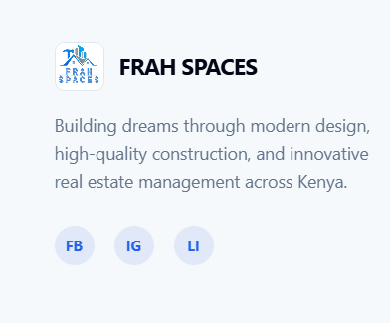


Replace below content with this list:
Pillar I: Design
- Architectural
- Structural
- Mechanical, Electrical and Plumbing (MEP)
- Interior
- Landscaping
Pillar II: Construction
- Engineering Procurement Construction (EPC/Turnkey)
- Labour-based
- Supplies
- Equipment
Pillar III: Project Management
- Construction Project Management
- Quality Control
- Progress Assessment
- Liaison
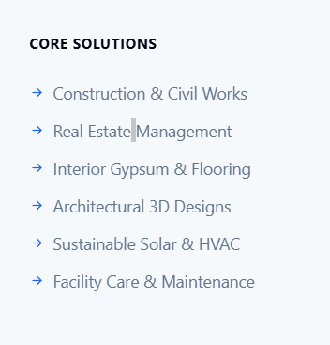

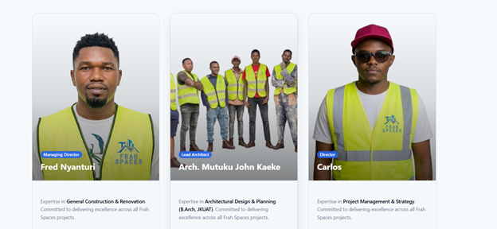

https://drive.google.com/file/d/1dYLW7JH3LwUOlphNOzzcc3tHb7OHnnhW/view?usp=drive_link --- James (Business Development Manager)

https://drive.google.com/file/d/1VLC1tA5gXZ4l-Naj_urKqcSctUDfHbou/view?usp=drive_link --- Arch. John (Project Architect)

https://drive.google.com/file/d/12z-C1Y4mR5U08vYPQ4G_13ChwPBrwebs/view?usp=drive_link
Shalom (Marketing & Client Relations Lead)

ADDING THIS:

